**Standard Operating Procedure**

**Excavator Operation**



**ODISHA MINING CORPORATION LTD.**

**KODINGAMALI BAUXITE MINE**

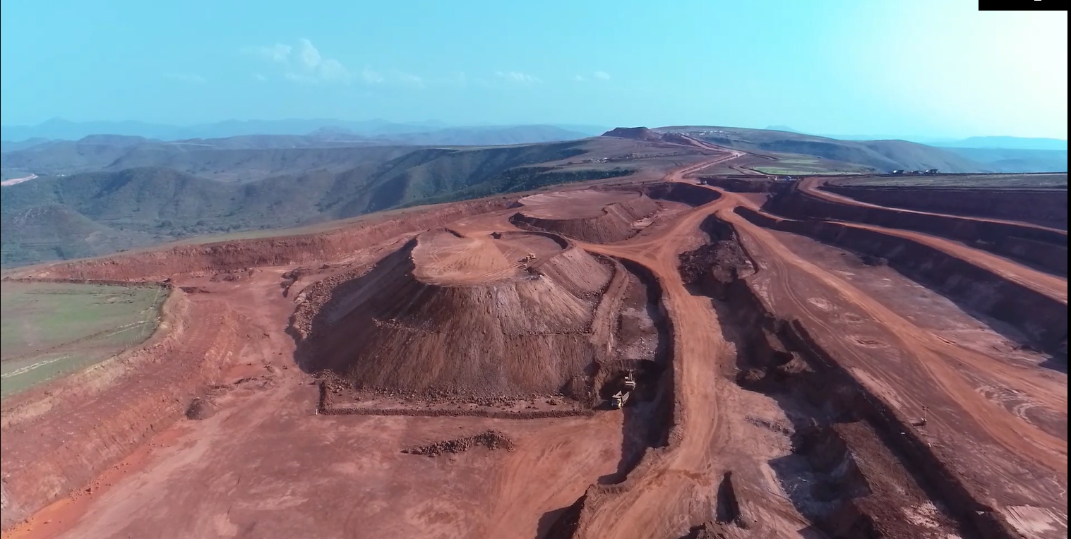

**Authorized By**

1. **Purpose:** This procedure is to establish and ensure safe operation for Excavator operating in mines.
2. **Responsibility:**

Mechanical in charge shall be overall in charge to ensure safety of HEMM operating in mines. He shall work along with Shift Incharge, Area Incharge and Safety officer to implement the standard across mine.

Operator shall be responsible to ensure safe operation of vehicle as per standard.

|  |  |
| --- | --- |
| 1. **PPE:** 2. Safety helmet 3. Safety shoe 4. Rubber Gloves 5. Nose Mask 6. Fluorescent jacket 7. Safety goggles. | **Training needs:**   1. Line of Fire 2. Traffic rules and Driving safety 3. Usage of PPEs 4. Fire Safety in HEMM 5. Safety and Health Hazard 6. Excavator Operation 7. Loading and Hauling Operation |

1. **Safety and Health Hazard**

* Slip/trip/fall.
* Head on Collision.
* Roll Over/Toppling of water tanker.
* Hitting to other Truck/Structure/Persons.
* Dust generation during Operation.
* Noise during Operation.
* Vibration during Operation.
* Diesel/ Hydraulic Oil - Inflammable, Fire hazards.
* Acid Batteries- Skin contact can lead to extensive and severe burns and highly toxic.

In order to avoid injuries to personal and damage to machinery, the following precautions are very important.

* Work required PPE i.e. with safety shoes, helmet, dust musk, fluorescent jacket suitable for long distance visibility etc.
* Pre Operation Safety features checklist.
* Regular Checks & Maintenance.
* Use seat belt while driving.

1. **Procedure:**
2. Operator is equipped with full safety gadgets needed for his operation (work) and Operator never starts any activities without equipping safety gadgets.
3. Operator has conducted full check up on safety devices and other parameters / vital components for his allocated excavator as per operator manual /manufacturer safety precaution s before starting the engine and to execute any operation , Operator determines & ensures that it is functioning in order / it is in safe working / serviceable condition.
4. Vital components like:-
5. The hydraulic system
6. The boom
7. The cabin
8. Ram and the Bucket
9. Hydraulic Jack
10. Sharp teeth of the bucket
11. Two control levers (lock / unlock)- control virtual all movements of the excavator.
12. Upper body of the excavator which swivels trough 360 degree by rotating the slewing ring.
13. Amongst the important components of the excavators hydraulic system are its :-
14. Filters
15. Pipes
16. Hoses
17. Seals
18. Valves
19. Cylinders & oil
20. Safety devices and parameters like:-
21. Horn and light
22. All gears & control levers
23. Lock & Unlock controls
24. Hydraulic pump
25. Bucket /Boom/ cylinder movement.
26. Level (quantity) of HSD in fuel tank.
27. Level (quantity) of hydraulics.
28. Level(quantity /quality) of coolant and brake oil
29. All pressures & temperatures parameters (while checking or operating).
30. Operator will ensure that there is no man within the range of movement of hydraulic components of the machine / immediate range of the attachment of equipment. Operator will not allow to any rank of man/men in close proximity to the bucket either it is cutting /digging or any operation. Several times accidents have taken place on account of above points Because it has been found that :-- WHEN BUCKET SLIPS IT MAY SWING TO SIDES (LEFT OR RIGHT) this causes by combination of accumulated tension in the arm of the hydraulic excavator and slight delay before the operator could react and stop the bucket. In this context it does not appear nothing is mechanically wrong nor did the operator to make an error or misunderstand a hand signal.
31. Heavy equipment’s to be operated minimum 1.5 meter from the edge of trenches / excavations.
32. Operator will ensure that:--
33. While Operator gives load (minerals / material) to hauling equipments / Crusher or Screen, he always tries to attain full fill factor of bucket.
34. After giving recommended load ( with respect to the capacity of hauling equipment), he gives appropriate signals( horns) to hauling equipment operator for proceeding his vehicle .
35. Operator will give appropriate signals (horn) to dumper operators / truck operators to place their vehicle in proper range & direction to give loads safely.
36. While Operator gives loads ( mineral /material ) to Crusher Hopper / Screen Hopper, Operator will ensure that he operate bucket in such way which does allow to promote spillage below the hopper .
37. Operator will ensure that he does not make delay deliberately while he operate excavator machine.
38. Operator will ensure that he never ignore any abnormalities are sensed while machine is in operation and he conveys the message to his supervisor / concerned authorities.
39. Operator will ensure that he follows all traffic rules applicable to mines / mines premises , Mines safety and warning signal while, he shifts / marches machine to another work place
40. Operator will ensure that he uses horns to alert the traffic coming from other side during shifting / marching excavator to another work place, whenever sight is intersected.
41. Operator will ensure that while negotiating a curve, he maintains low speed and select a turning radius commensurate with speed and to adjust crawling component of machine.
42. While operates up or down gradient, he keeps machine in low gear range (by controlling levers) to avoid engine over race and consequent damage.
43. Operator will ensure that there is no leakage from hoses / connections while he operates excavator.
44. Operator will ensure that filters of the hydraulic system is working smoothly, no cavitation is producing during operation.
45. Filters are filtrate regularly / replaced as applicable with running hours of machine.
46. Operator will try to ensure the availability through his supervisor / maintenance personnel (spares) at least one piece of pipes, hoses & seals which becomes important sometimes as hydraulic hoses may brust under pressure. And connection of hoses to machine parts is the most vulnerable points.
47. Operator ensures to perform his duty as detailed in Job description for his category.
48. Operator ensures to obey instructions passed to him by his supervisor /superior/authorities.

***Note: Report immediately to Supervisor, Shift Incharge and Safety officer for any incident/accident.***